SSL Certificate
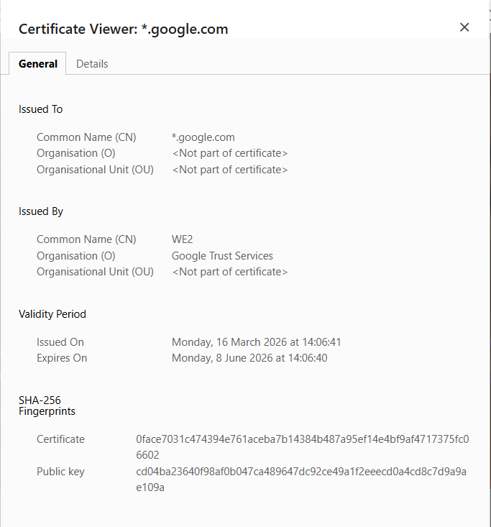
🔐 Can we decrypt an SSL Certificate?
Short answer: ❌ No — because there’s nothing to “decrypt.”
An SSL/TLS certificate (like the one you showed for *.google.com) is not encrypted data. It is a public document.

🧠 What a Certificate Actually Is
An SSL certificate contains:
- Domain name (e.g. *.google.com)
- Public key
- Issuer (e.g. Google Trust Services)
- Validity dates
- Digital signature from a Certificate Authority (CA)
👉 All of this is plain, readable data — not secret.
That’s why your browser can display it directly.

🔑 What is “Encrypted” then?
In HTTPS, the certificate is used for encryption, but it is not itself encrypted.
Here’s the flow:
- Browser connects to server
- Server sends its certificate (public key)
- Browser:
  - Verifies it (CA signature)
  - Uses the public key to encrypt a session key
- Server decrypts using its private key
- Both now use symmetric encryption (fast)

🔍 Why You Cannot Decrypt It
Because:
- Certificate contains public key (not private key)
- Encryption/decryption requires:
  - Public key → encrypt
  - Private key → decrypt
👉 The private key is NEVER shared — only the server has it.

⚠️ Important Security Point
If someone could “decrypt the certificate,” it would mean:
- They somehow extracted the private key
- That would completely break HTTPS security
But in reality:
- Certificates are meant to be public
- Only private keys are secret

🧩 Simple Analogy
- Certificate = 🔓 Open lock (public key)
- Private key = 🔑 Secret key
Anyone can see the lock
Only the owner has the key

🧪 What You Can Do With a Certificate
You can:
- View it ✅ (as you did)
- Extract public key ✅
- Verify issuer signature ✅
You cannot:
- Get private key ❌
- Decrypt HTTPS traffic ❌ (without private key)

